344C5
Popa Iulia

Laboratory 3 - I/O Monitoring (Linux)

Task 01. Rotational delay - IOPS calculations

- Calculate rotational delay
- Divide 5400 RPM by 60 seconds: 5400/60 = 90 RPS
- Convert 1 of 90 to decimal: 1/90 = 0.0111 seconds per Rotation
- Multiply the seconds per rotation by 1000 milliseconds (11.1 MS per rotation).
- Divide the total in half (RD is considered half a revolution around a disk): 11.1/2 = 5.55 MS
- Add an average of 5.55 MS for seek time: 5.55 MS + 5.55 MS = 11.1 MS
- Add 5.55 MS for latency (internal transfer): 11.1 MS + 5.55 MS = 16.65 MS
- Divide 1000 MS by 13 MS per I/O: 1000/16.65 = 60.06 IOPS
Written like this looked pretty nice!
But...
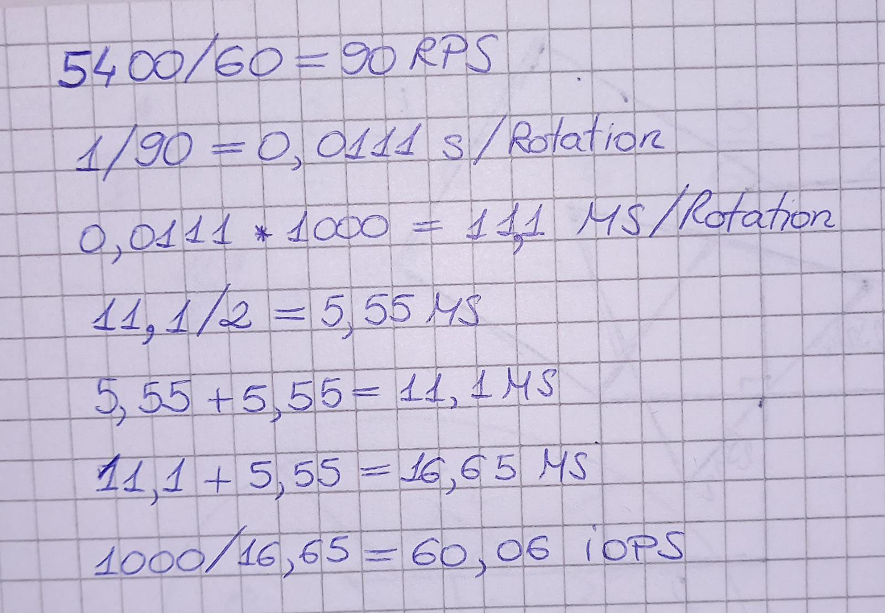
I think the Internet says that it should be between 50 and 75 IOPS, so 60 should be ok!

Task 02. iostat & iotop
iostat -xdm:
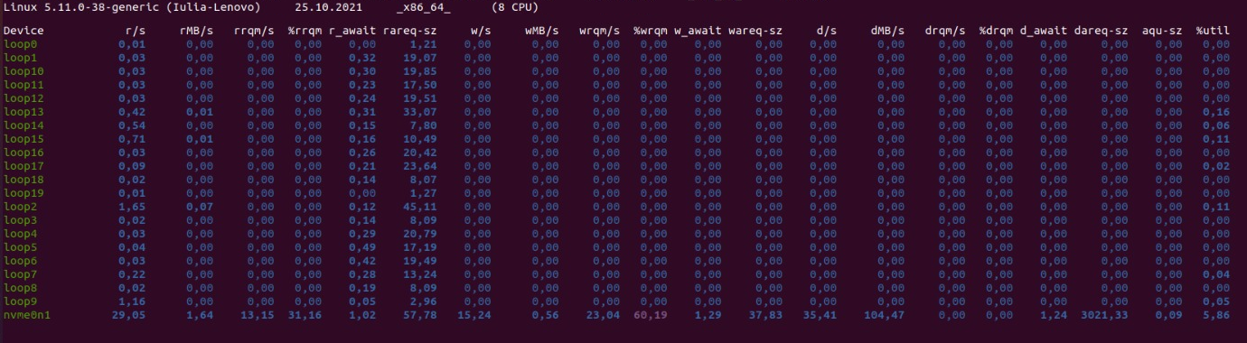
iostat -xdm -p sda:
🤨🤨🤨
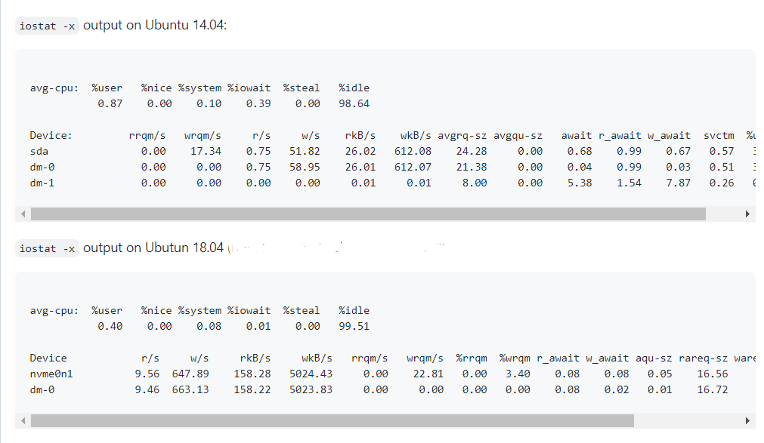
iostat -x 1 5:
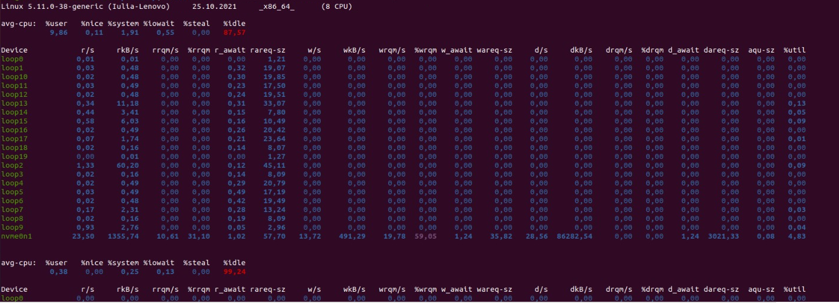
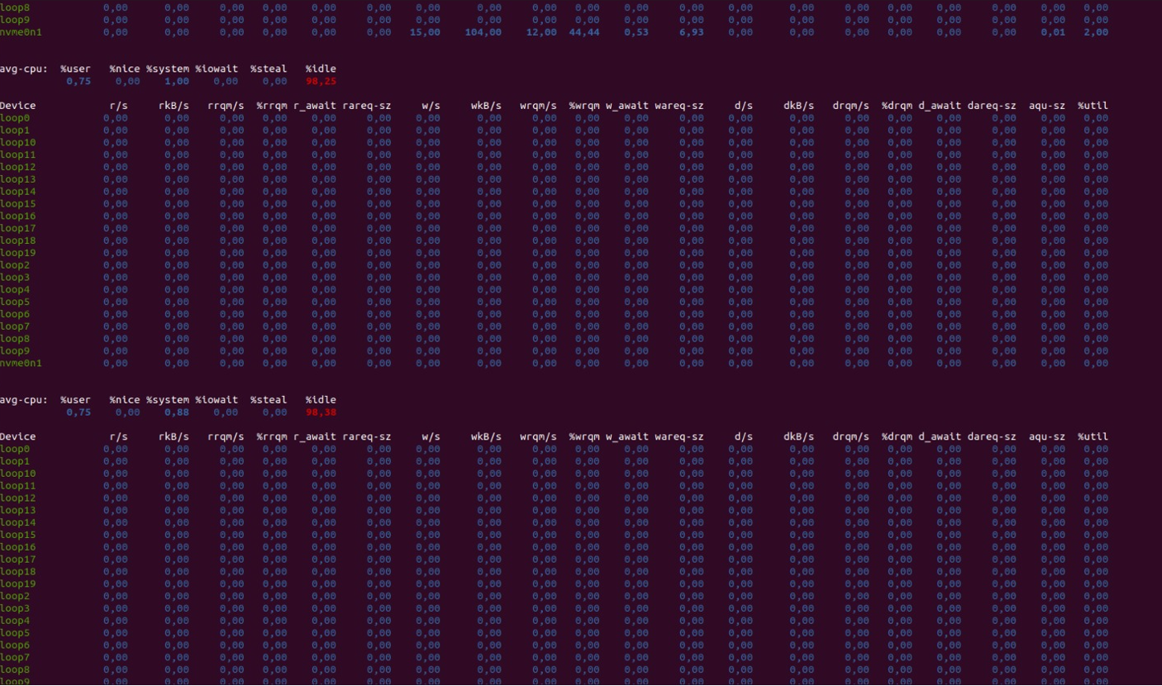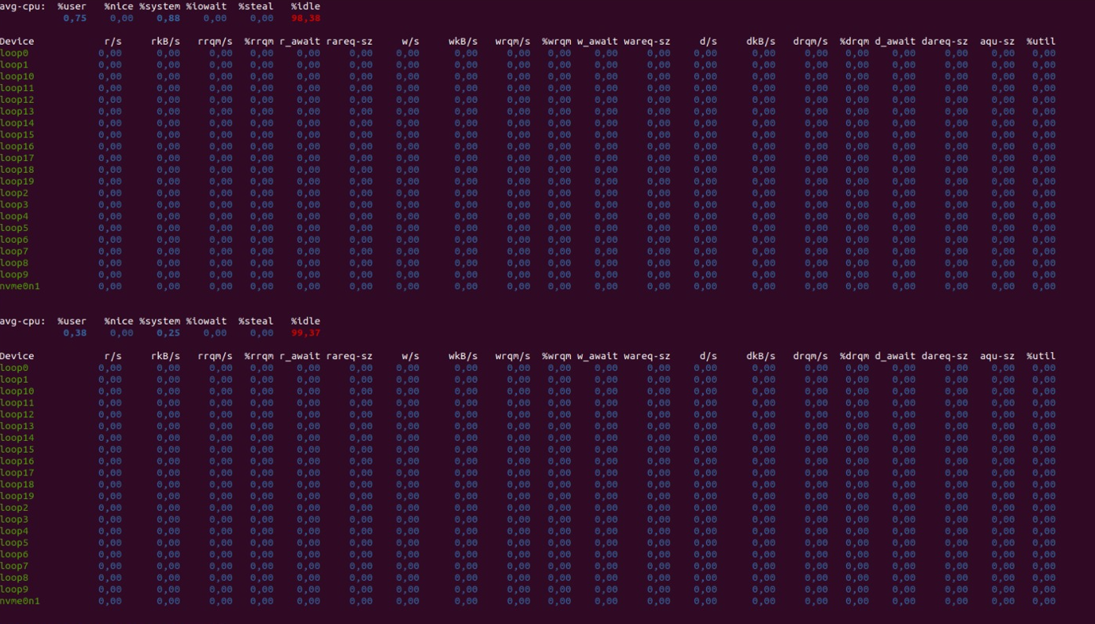
- Monitoring the behaviour with Iostat
Last two outputs:
- 1355.74 rkB/s and 23.50 r/s
1355.74 / 23.50 = 57.69 kB per read
- 104 wkB/s and 15 w/s
104 / 15 = 6.93 kB data per write
read speed >>> write speed

df -kh /dev/loop*:
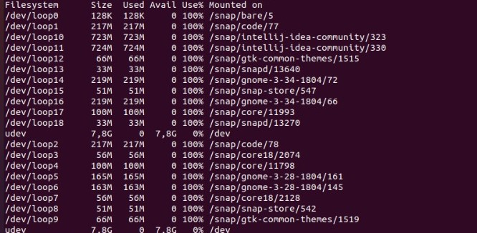

B. Monitoring the behaviour with Iotop
sudo iotop:
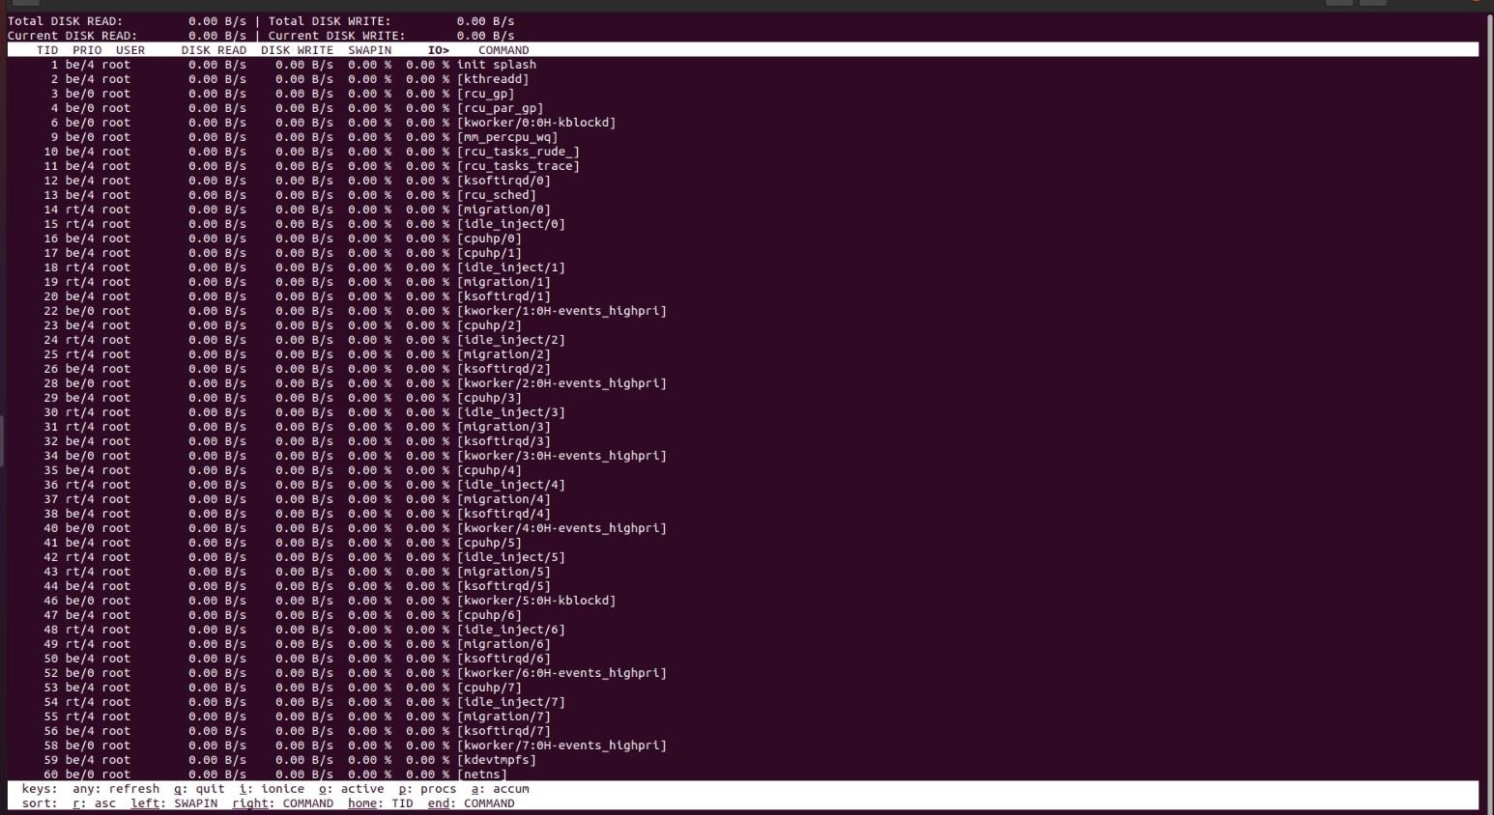

While the script is running, started iotop and ps -a (to find the process PID and PPID for dummy.sh):
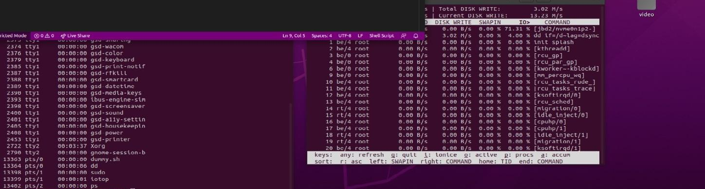
Used the kill command for the process that runs the script and also for the parent process:
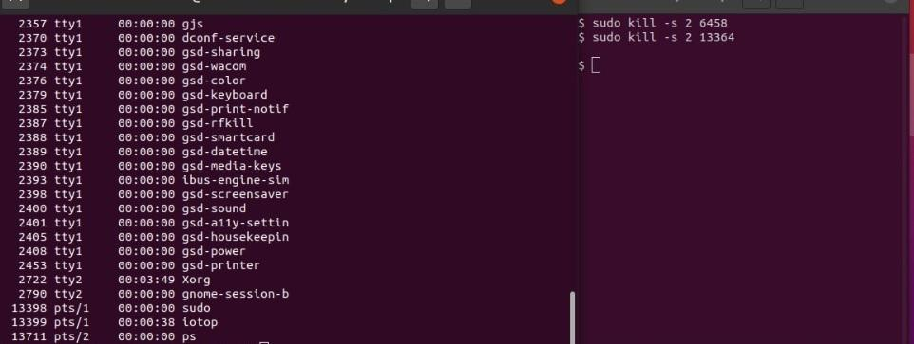

Task 03. RAM disk
- df -Th:
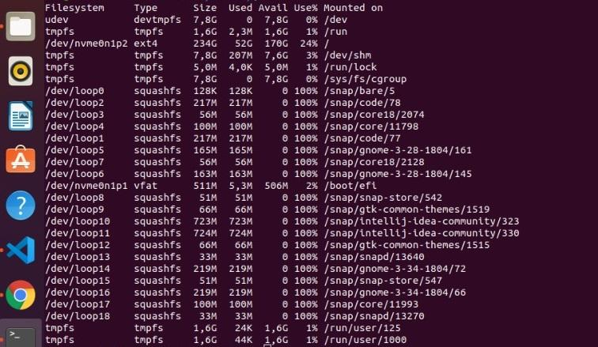

Created a 1Gb tmpfs ramdisk with an ext4 file system and mounted it at /mnt/ramdisk. Then used df to check:
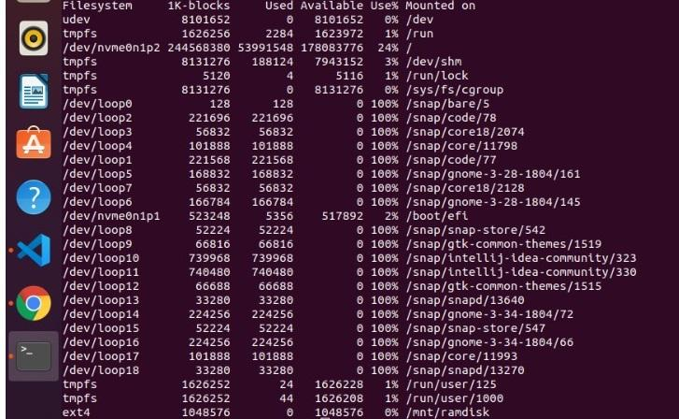

- Pipe View & RAM Disk
Used the two commands to generate the files:

- pv /dev/urandom | dd of=mnt/ramdisk/rand bs=2048 count=$((512 * 1024 * 1024 / 2048)):
262144+0 records in56MiB/s] [ <=> ]
262144+0 records out
536870912 bytes (537 MB, 512 MiB) copied, 3,27098 s, 164 MB/s
512MiB 0:00:03 [ 156MiB/s] [ <=>
]

- pv /dev/urandom | dd of=home/iulia/rand bs=2048 count=$((512 * 1024 * 1024 / 2048)):
262144+0 records in44MiB/s] [ <=> ]
262144+0 records out
536870912 bytes (537 MB, 512 MiB) copied, 3,57407 s, 150 MB/s
512MiB 0:00:03 [ 143MiB/s] [ <=> ]

Checked using the df command:
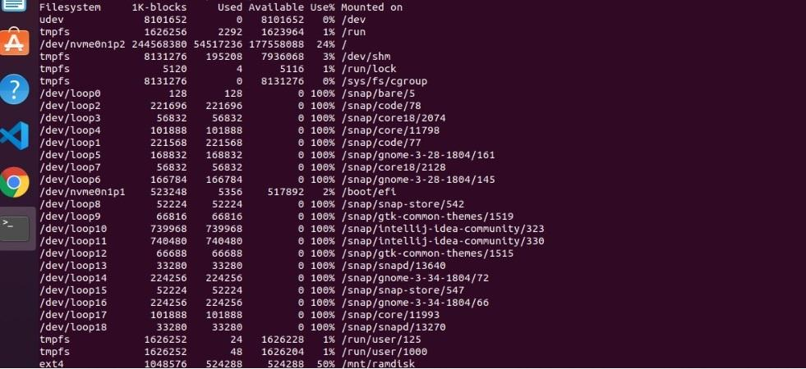
Time and speed are approximately equal. In the first case, the speed is bigger than in the second case.

Task 04. Perf & fuzzing
- Fuzzing with AFL
Ran all the commands in the terminal and got the following result:
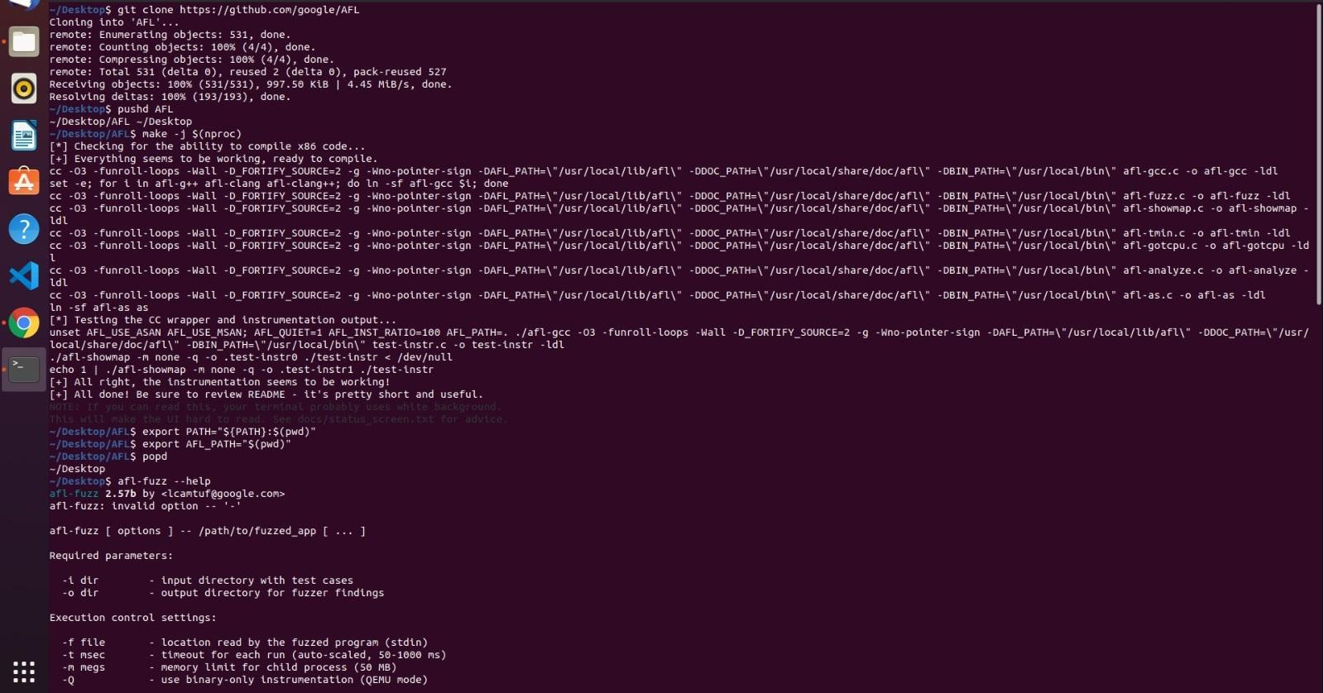
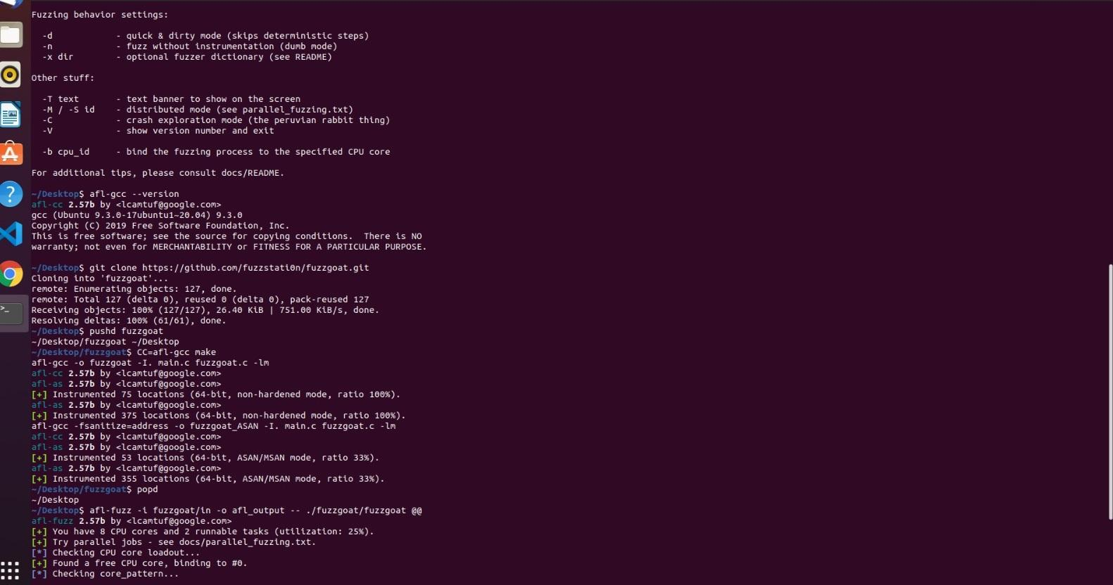
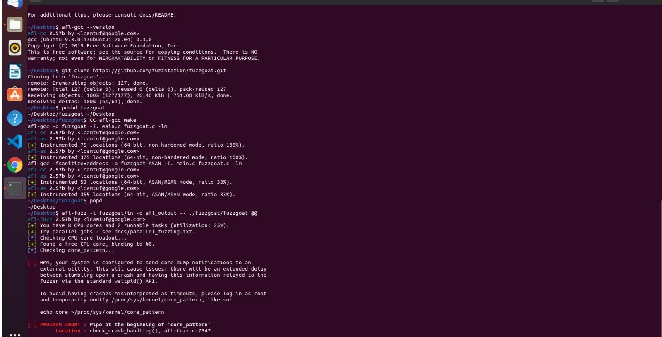
- Profile AFL
Used the command perf script -F pid (https://linux.die.net/man/1/perf-script):
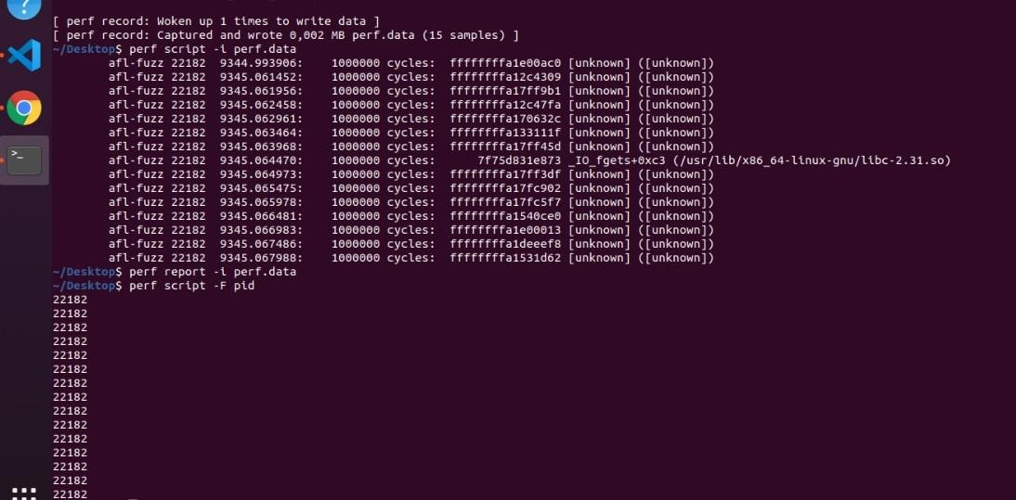
Tadam! 🎉🎉🎉
Task 05. Feedback


